***The graph below shows the percentage of part-time workers in each country of the United Kingdom in 1980 and 2010.***

***Summarise the information by selecting and reporting the main features, and make comparisons where relevant.***

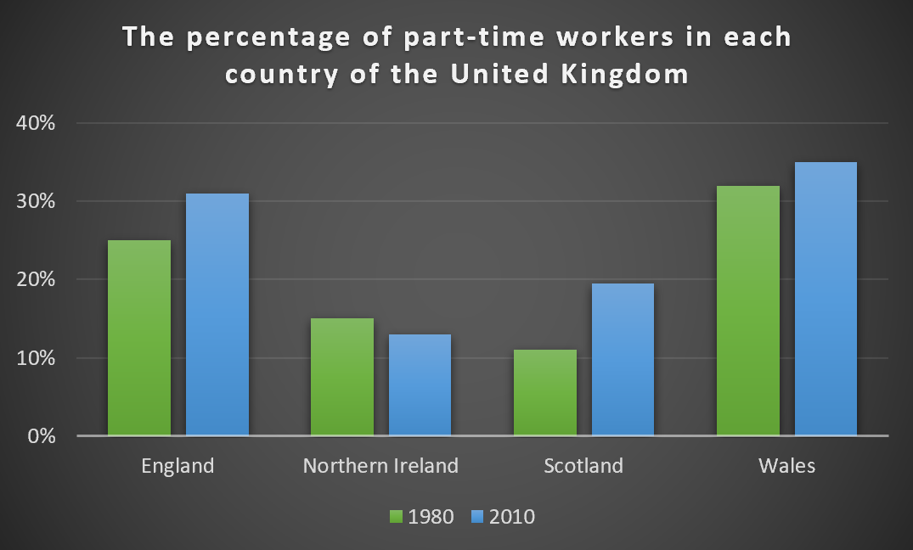

**Model answer**

The bar chart shows the percentage of people who have part-time jobs in the countries that make up the United Kingdom, both in 1980 and in 2010. There'has generally been a small increase in part-time workers from 1980 to 2010, except in Northern Ireland. The graph also shows that England and Wales have far more part-time workers than Northern Ireland and Scotland.

In 1980, 25% of people in England worked part time. The only country with a greater percentage of part-time workers was Wales, with around 33% working part time. Both countries saw an increase in the percentage of people working part time in 2010. In England, the percentage rose to over 30% and in Wales percentage rose to just over 35%.

Scotland had the smallest percentage of part-time workers in 1980, with just over ten per cent. However, this rose to almost 20% in 2010 which is a large increase. Lastly, Northern Ireland was the only country which had a decreasing percentage of part-time workers. In 1980, it had around 15% of people in part-time work. This decreased by a couple of per cent in 2010.

1. **The pie charts below show the average household expenditures in Japan and Malaysia in the year 2010.** Summarize the information by selecting and reporting the main features, and make comparisons where relevant.

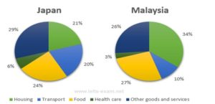

The two pie charts show the proportion of money spent on various household necessities in Malaysia and Japan in 2010. The date is calibrated in percentage.

Overall, the data indicates that in both cases food, housing and other goods and services were the main expenses while, both countries spent least on health care.

It can be clearly seen from the chart, in Malaysia the greatest proportion of expenditure (34%) was on housing, while in Japan housing accounted for just 21% of the total. Followed by in Japan the greatest single expense was other goods and services at 29%, compared with 26% in Malaysia.

Moreover, food came at second place in Japan, at 24%, while in Malaysia the actual proportion was higher (27%). In Japan another major expense was transport, at 20%, but this was much lower in Malaysia (10%). Surprisingly, in both countries the smallest percentage of expenditure was on health care.

***The chart below shows the proportions of graduates from Brighton University in 2019 entering different employment sectors.***

***Summarise the information by selecting and reporting the main features, and make comparisons where relevant.***

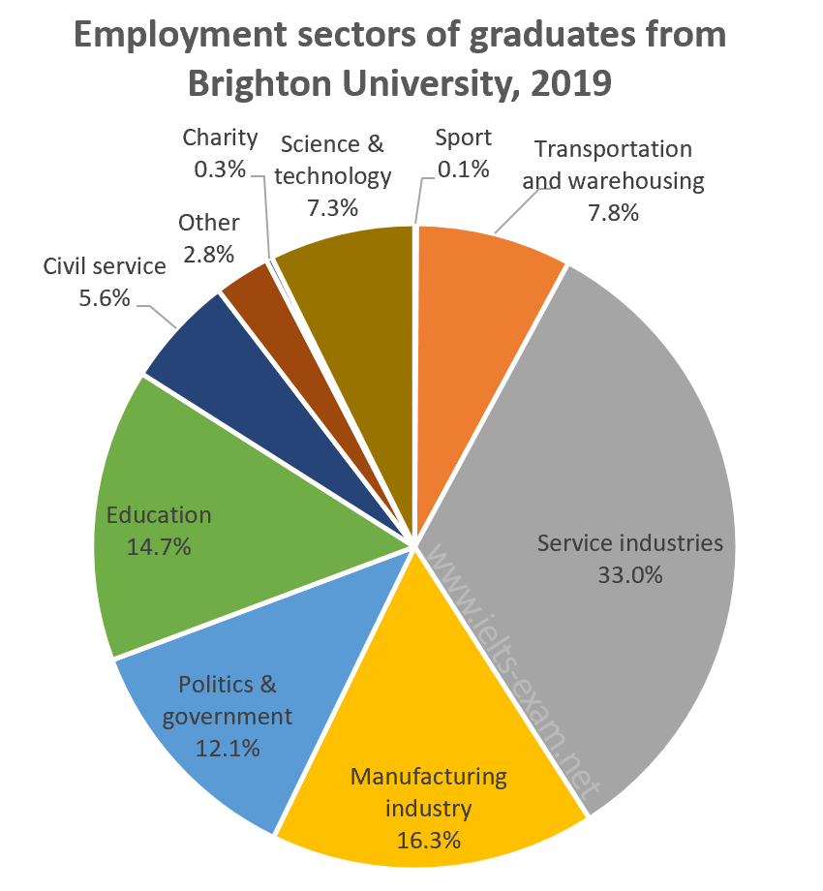

### Model answer

The pie chart illustrates the career choices of Brighton University's 2019 graduates, giving the percentages who worked in each of various sectors after finishing university. Overwhelmingly, industry and government were the most popular choices.

Just under half the students went into industry, with service industries attracting more Brighton graduates than any other sector by far — almost a third (33.0%). About half that number (16.3%) took jobs in manufacturing.

Politics and public service were the next most popular choice, accounting for nearly a fifth of graduates. Just over 12% went into politics and a further 5.6% chose the civil service. The other significant career choices were education (about 15%) and two others: transportation and warehousing, with 7.8%; and science and technology with 7.3%.

The least popular choices included work in the charitable sector and careers in sport, both of which were chosen by well under 1% of graduates. Finally, 2.8% entered work in other, unspecified, sectors.

***The diagram illustrates how bees produce honey.***

***Summarise the information by selecting and reporting the main features, and make comparisons where relevant.***